6.2.1 Quality improvement strategies adopted by the institution for each of the following (with in 100 words each):
- Curriculum Development

The institution improves curriculum quality by collecting feedback from students, teachers, and alumni during meetings and classroom interactions. Suggestions are discussed in staff meetings
Faculty members attend workshops and orientation programs to understand curriculum changes and implement them effectively. The college adds simple value-added activities through guest talks, and
Regular monitoring of learning outcomes and student performance helps identify areas for improvement, ensuring that the curriculum remains relevant and supportive for small-scale institutional needs.
At the beginning of every academic year, the faculty reviews the existing university curriculum and assesses its suitability for the current student group. Teachers analyze the syllabus content, recommend teaching plans, and identify areas where students may need extra support. Feedback is gathered informally through classroom interactions, student mentoring, suggestion boxes, and periodic discussions.
Curriculum monitoring is another important step followed by the institution. Continuous evaluation of student performance through tests, assignments, and classroom response helps faculty understand the effectiveness of curriculum delivery. Learning outcomes are periodically reviewed to ensure that students are achieving the expected competencies. Special attention is given to slow learners through remedial classes, ensuring that the curriculum remains accessible to all.

- Teaching and Learning

The institution adopts practical and student-centered teaching and learning practices
The primary focus is on delivering quality education through committed faculty, a supportive learning environment, and continuous monitoring of student progress.
At the start of each academic year, departments prepare a teaching plan based on the affiliating university syllabus. Faculty members break the content into manageable units and schedule classes to ensure timely completion of portions.
Classroom teaching primarily uses the chalk-and-talk method, which remains effective given the modest infrastructure. However, wherever possible, faculty integrate simple ICT tools such as PowerPoint presentations, short videos, audio lectures, and online resources
To make learning more interactive, faculty conduct group discussions, class seminars, quiz competitions, and subject-related activities that allow students to participate actively. The institution places special emphasis on helping slow learners. Remedial classes revision sessions are arranged to strengthen their understanding
Overall, the teaching and learning system of the institution focuses on accessibility, student
engagement, and continuous improvement. With dedicated faculty, supportive mentoring, modest but
effective use of technology, and regular monitoring, the college ensures that students receive a
meaningful learning experience despite limited infrastructure.

- Examination and Evaluation

At the beginning of the semester, students are informed about the examination structure, internal assessment methods, and evaluation criteria. The college conducts internal examinations in a systematic manner. The Examination Committee prepares a schedule, allocates invigilators, and ensures availability of necessary materials such as answer booklets, seating arrangements, and attendance sheets for university examinations; the institution strictly follows guidelines regarding hall arrangements, invigilation, and confidentiality. The principal appoints Chief Superintendent and assistant staff to oversee the process. The college ensures safe storage and timely dispatch of question papers and answer scripts. CCTV-surveilled rooms or restricted-access spaces are used wherever possible to maintain security, Practical examinations are conducted with care, especially for science and vocational subjects. External examiners appointed by the university are supported by internal faculty. Laboratory records, viva-voce, and demonstrations are evaluated methodically. Departments ensure that students receive adequate practical training beforehand despite limited lab facilities, making optimum use of available equipment. evaluation, photocopy, and grievance redressal mechanisms are explained to students. Faculty help them apply for revaluation or clarify doubts regarding results Overall, the institution maintains a fair, transparent, and student-oriented examination and evaluation system. Through careful planning, committed faculty involvement, timely evaluations, and supportive monitoring, the college ensures smooth conduct of examinations despite limited infrastructure.

- Research and Development

Faculty members are encouraged to engage in academic research, publish papers, attend seminars, and participate in online or regional conferences. The institution motivates teachers to register for Ph.D. programs, undertake minor research studies, and contribute chapters or articles to journals. Even without large funding, teachers use available resources, libraries, and digital platforms to conduct small research projects related to their subjects or local issues. The college supports them by providing duty leave, internet access, and recommendation letters for attending workshops or presenting papers.
The library supports research by providing reference books, newspapers, journals, e-resources, and internet facilities. Teachers and students are encouraged to use open-access journals, government portals, and digital libraries for literature review.

- Library, ICT and Physical Infrastructure / Instrumentation

Library Development:
The college library is the main resource center for students and faculty. It houses textbooks, reference books, journals, newspapers, and previous question papers relevant to the courses offered. Despite being small, the library operates efficiently with a simple borrowing system and extended access during examination periods. The institution updates its collection every year by adding new titles based on departmental recommendations and student demand. The library maintains a student-friendly environment with reading spaces, proper ventilation, and a quiet atmosphere. Digital access is provided through e-resources, open-access platforms, and online academic materials, enabling students to expand their learning beyond printed books.
ICT Facilities:
Even with limited infrastructure, the institution promotes ICT-enabled learning through the use of available digital tools and technology. A few classrooms are equipped with projectors and computers to support multimedia teaching. Teachers use PowerPoint presentations, online videos, and e-content to make lessons more engaging and interactive. The computer lab, though modest, offers basic training in digital skills and supports academic work, online registration, exam form filling, and accessing e-learning resources. Internet access is provided to faculty and students in the library, computer lab, and staff room for academic purposes. Departments also use simple ICT tools, WhatsApp groups to share notes, assignments, and important information with students.
Physical Infrastructure:
The college campus is small but well-maintained. Basic facilities such as classrooms, staff rooms, laboratories (where applicable), administrative offices, and common areas are arranged to provide a comfortable learning environment. Classrooms are adequately furnished and regularly cleaned to maintain hygiene and discipline.
- Human Resource Management

Recruitment of teaching and non-teaching staff is carried out as per government, management, and affiliating university guidelines. The college ensures that qualified and competent faculty are appointed to meet academic requirements.
Staff development is encouraged through participation in orientation programs, refresher courses, FDPs, and workshops to upgrade their knowledge and teaching skills. The institution promotes a friendly work environment where faculty can openly discuss academic needs and challenges.
Workload is distributed fairly, and departments are given autonomy to plan academic activities. Regular staff meetings help in reviewing progress, addressing issues, and planning improvements. Mentoring, teamwork, and shared responsibilities ensure smooth functioning despite limited resources.
Non-teaching staff are trained in administrative procedures, record maintenance, and use of ICT tools, enabling efficient office management. The institution also motivates staff by recognizing their contributions through appreciation, assigning roles in committees, and involving them in decision-making processes.
- Industry Interaction / Collaboration
The institution strengthens industry linkages through MoUs, internships, industrial visits, guest lectures, and collaborative projects. Industry experts participate in curriculum design, skill development programmes, and placement activities. Centres for innovation and incubation promote entrepreneurship. Joint certification courses, hands-on training, and workshops bridge the gap between academic learning and industrial needs. Feedback from employers helps refine teaching–learning and enhance employability skills.

Departments regularly invite local industry professionals, entrepreneurs, and skilled workers to deliver guest lectures, demonstrations, and career guidance sessions. These interactions help students understand workplace expectations, current trends, and basic employability skills
- Admission of Students
The institution follows a transparent, merit-based, and inclusive admission process as per government/ regulatory norms. Online admission systems ensure efficiency and accessibility. Information brochures, counselling sessions, and help desks assist applicants in making informed choices. Reservation policies, scholarships, and financial-aid support equity and diversity. Data analysis of admission trends helps in planning programmes and outreach activities. Grievance-redressal mechanisms ensure fairness during the admission process.

the institution follows a transparent, student-friendly admission process that aligns with the guidelines of the affiliating university and the state government. The college caters mainly to rural and economically weaker sections; hence, the admission procedure is kept simple, accessible, and supportive. Information regarding courses, eligibility, fees, and required documents is communicated through notice boards, the college website, and local outreach.
Admissions are conducted on a merit basis, giving priority to students from the local community. The college admission committee oversees the entire process, verifies documents, and provides guidance to students and parents. Faculty members assist applicants in choosing suitable courses based on their interests, previous academic performance, and career goals.
The institution ensures inclusiveness by admitting students without discrimination and by reserving seats for SC/ST/OBC/EWS categories as per government norms. Fee concessions and scholarships are promoted to encourage students from economically backward backgrounds to pursue higher education.

6.2.2: Implementation of e-governance in areas of operations:
Online Communication System
- All official communication takes place through:
- Institutional email system
- WhatsApp groups for quick internal communication
- College website updates
- Administrative information is disseminated more quickly and efficiently.
Office Automation
- Digital attendance (biometric)
- Accounting and fee management software
- Online issuance of certificates (bonafide, TC, N.O.C)

- Administration
Online Communication System
All official communication takes place through:
- Institutional email system
- WhatsApp groups for quick internal communication
- College website updates
Office Automation
- Digital attendance (biometric)
- Accounting and fee management software
- Online issuance of certificates (bonafide, TC, character certificate)

- Finance and Accounts
- Digital Accounting System
- The college uses accounting software such as Tally for:
- Recording transactions
- Maintaining ledgers
- Generating financial statements
- Income–expenditure tracking
- This minimizes manual errors and ensures accurate documentation.

e-Budgeting and Financial Planning
- Annual budgets, departmental allocations, and expenditure reports are prepared using:
  - Excel/
- Digital Audit and Compliance
- external audits use digital documentation:
- Soft copies of income–expenditure statements
- Digital vouchers and receipts
- e-submission of audit reports

.

- Student Admission and Support
- Online Student Database Management
Student records such as:
- Personal details
- Academic history
- Certificates

- Student Helpline
- Dedicated WhatsApp number / Email ID for admission queries.
- Quick response mechanism through office staff or admission committee.

- Examination
  - Online Examination Registration
- Students register for semester/annual examinations through:
University examination portal

Online Exam Timetables and Notifications
- Examination schedules, and important instructions are uploaded to: SMS/WhatsApp groups to Ensures instant communication and wide reach.
University Examination Linkage
- All university examination-related activities—registration, hall ticket downloads, photo uploading, and results—are coordinated digitally through the university portal.
- This facilitates seamless communication between the college and the affiliating university.

RELATED DOCUMENTS:
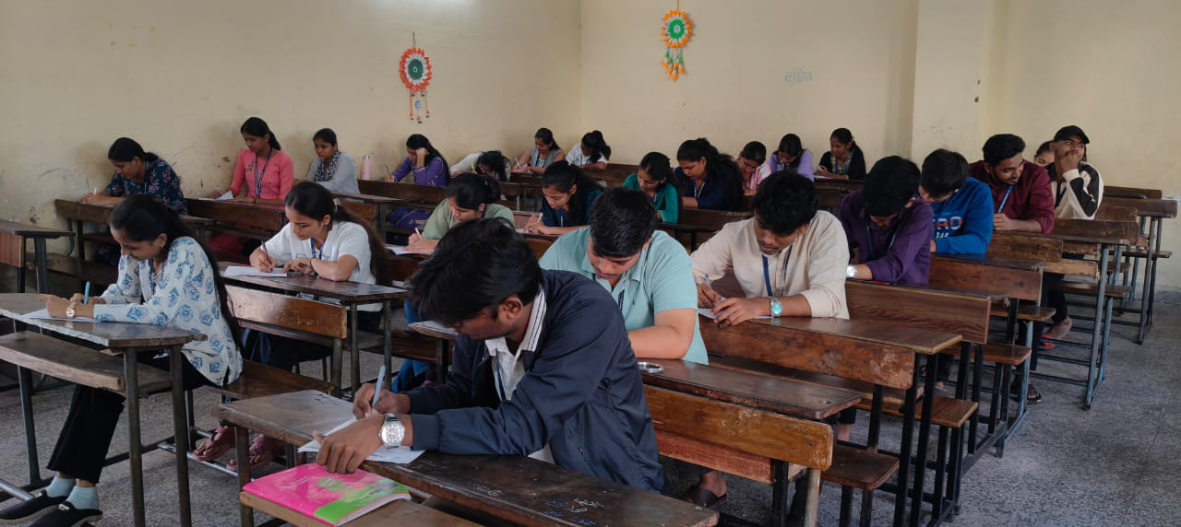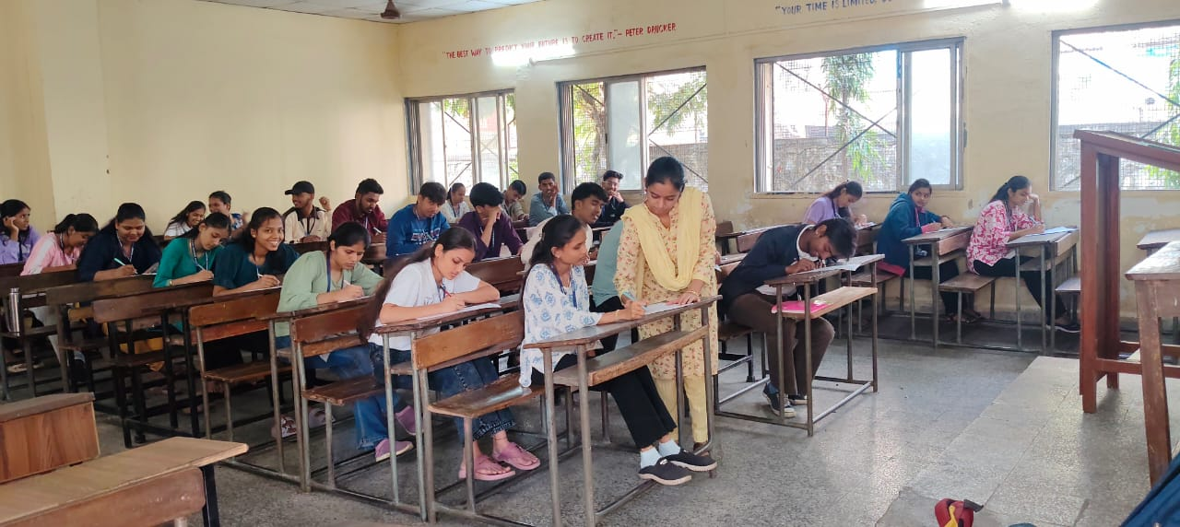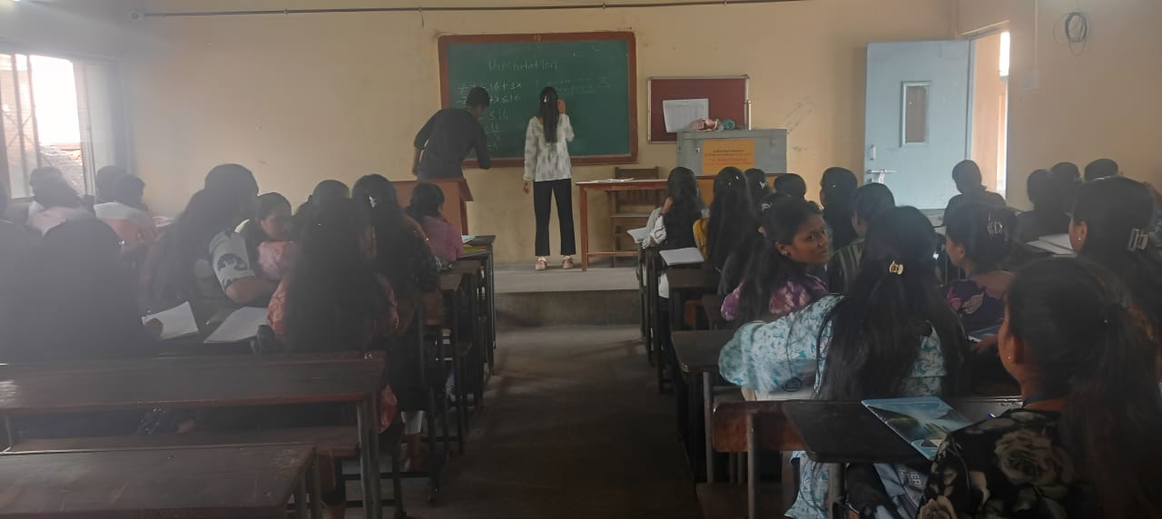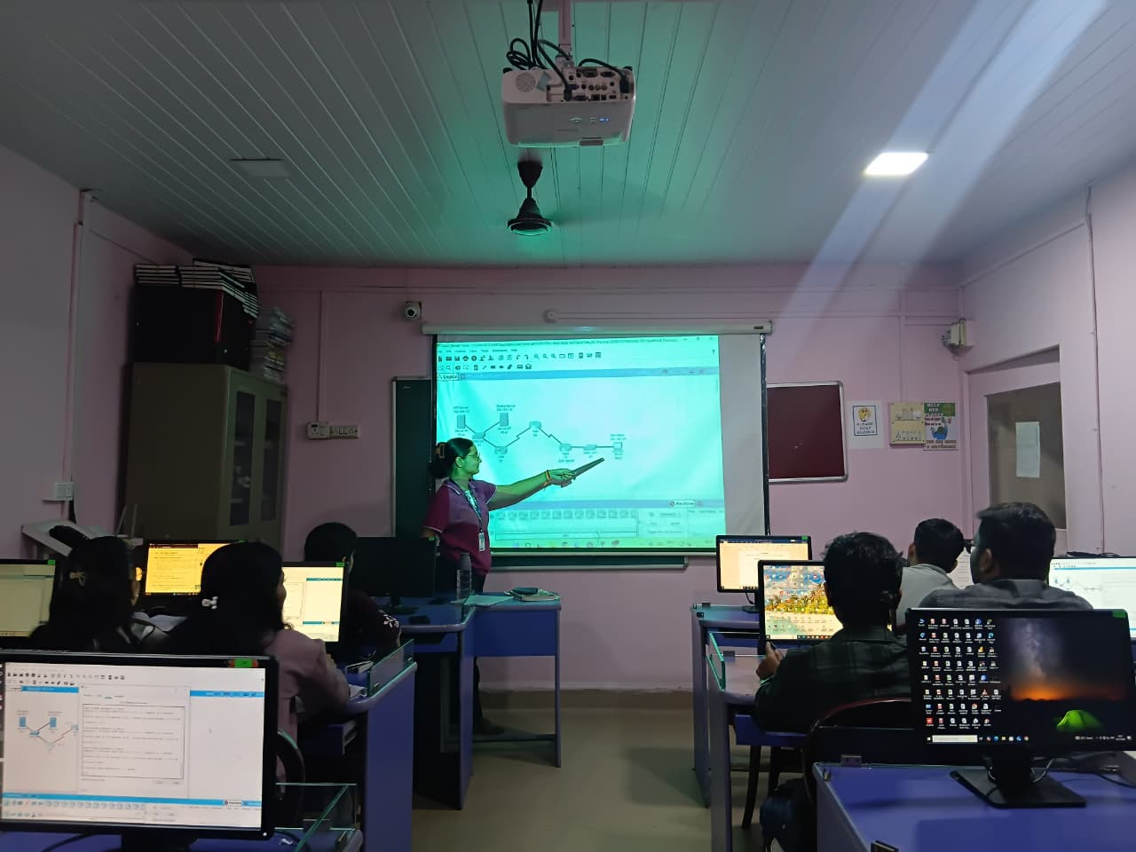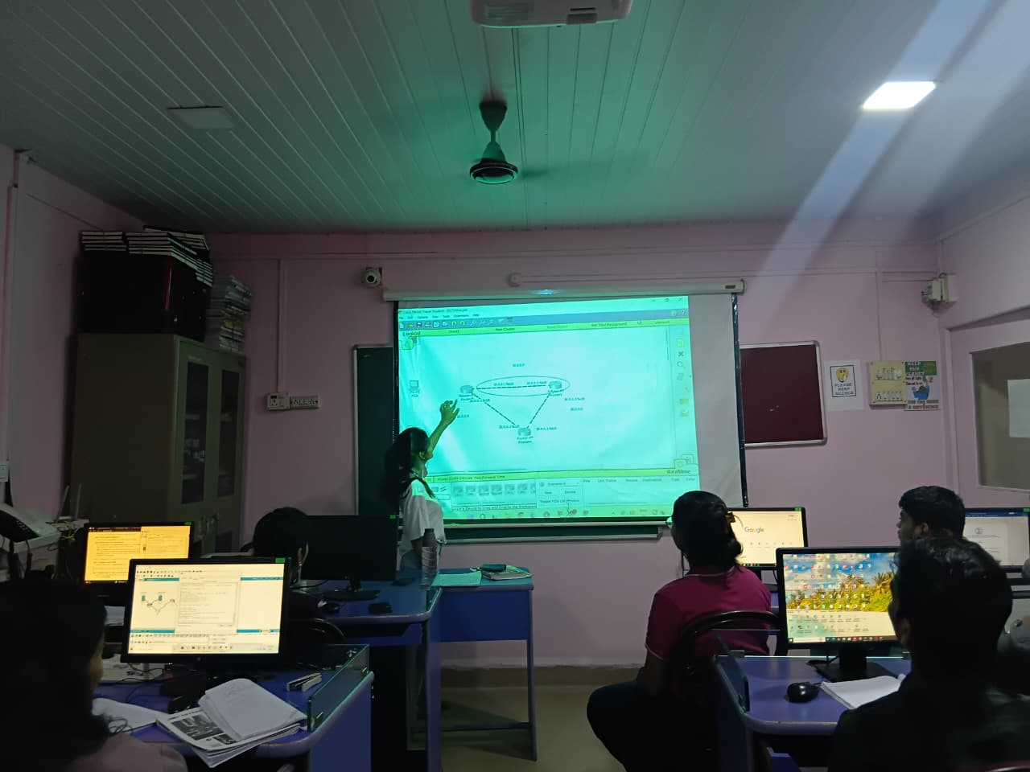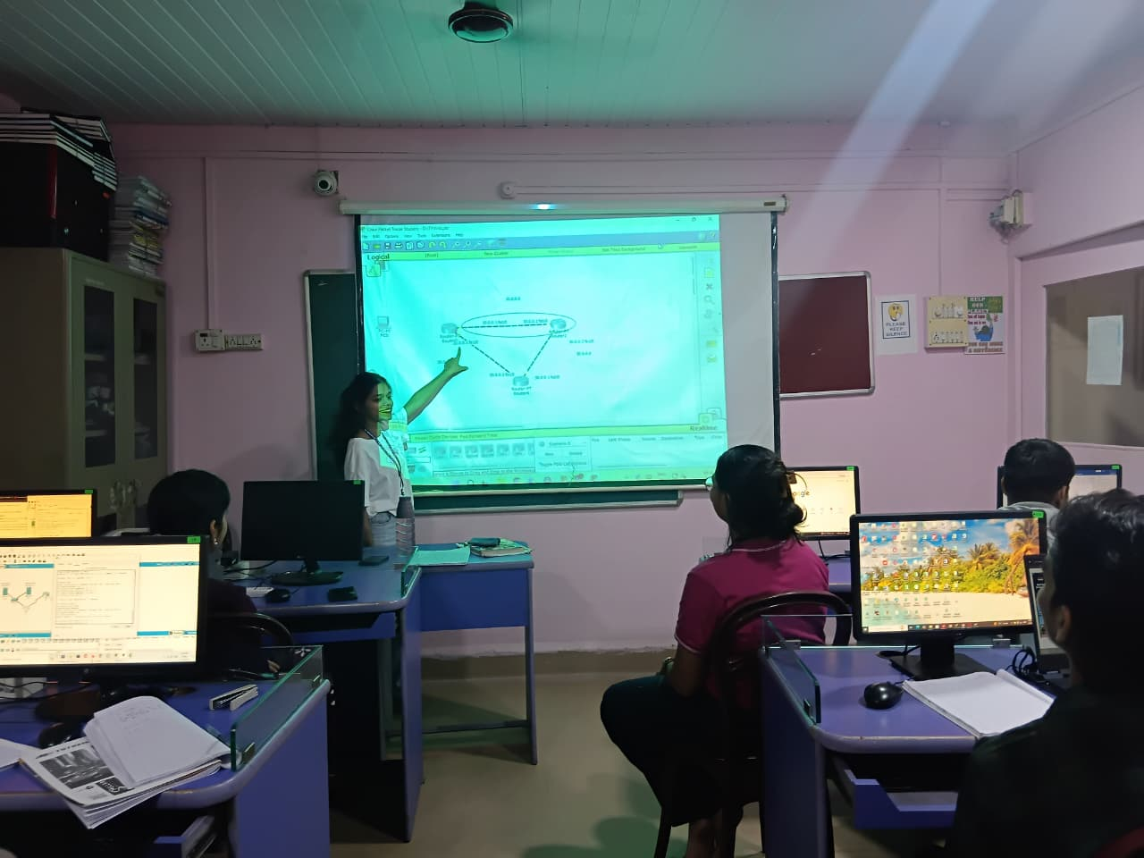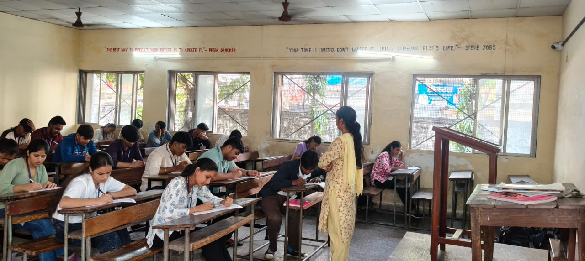

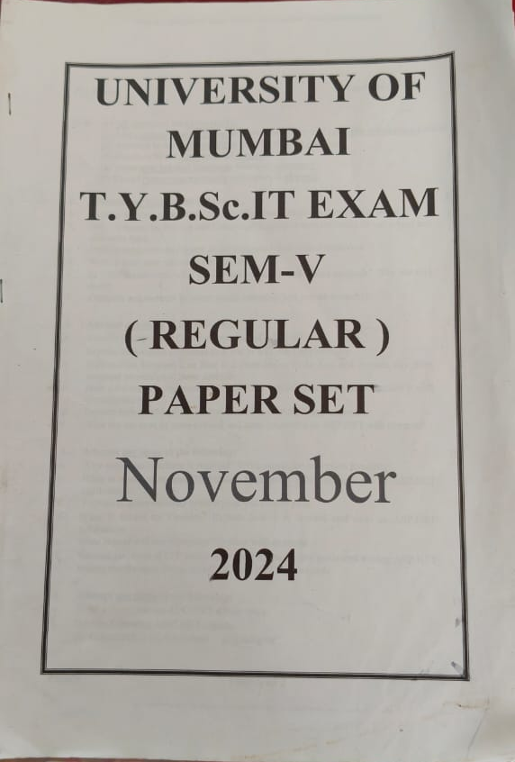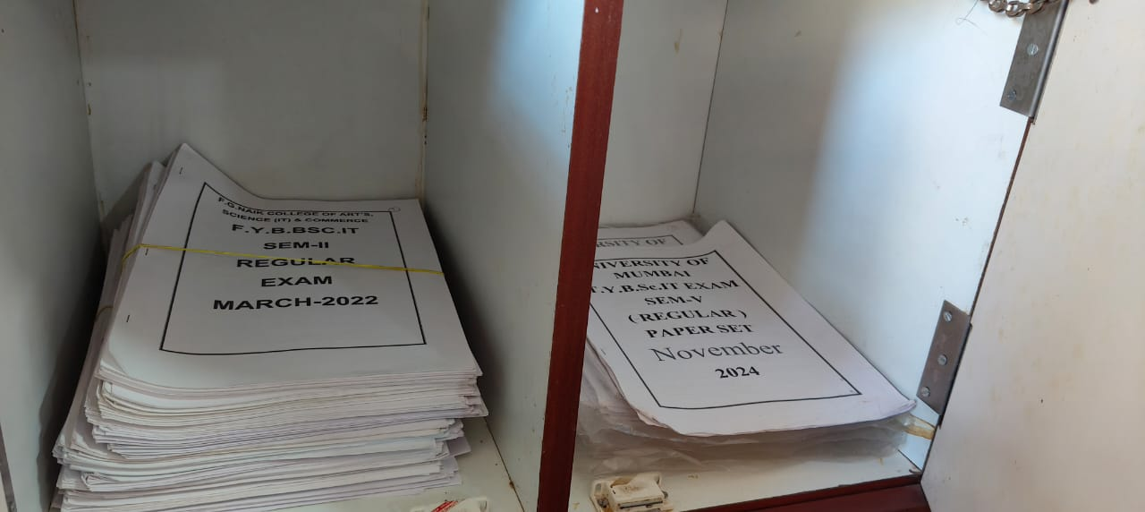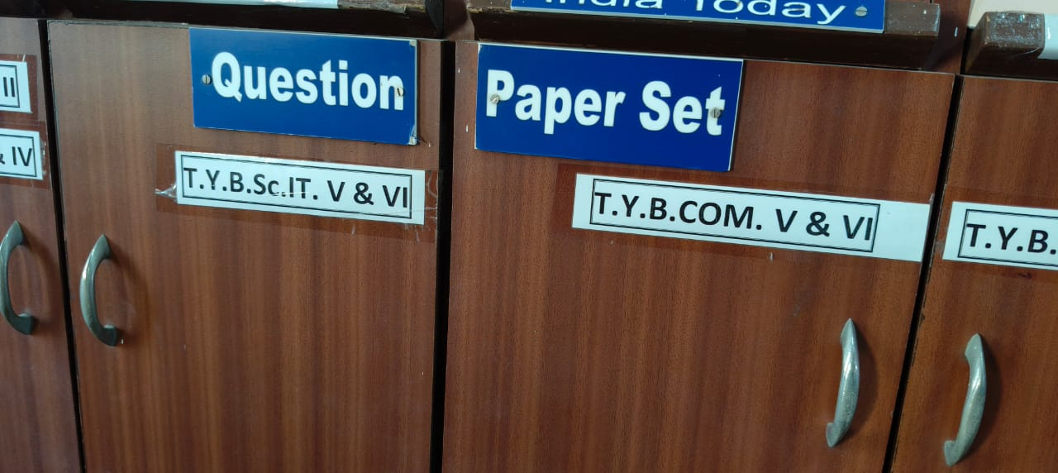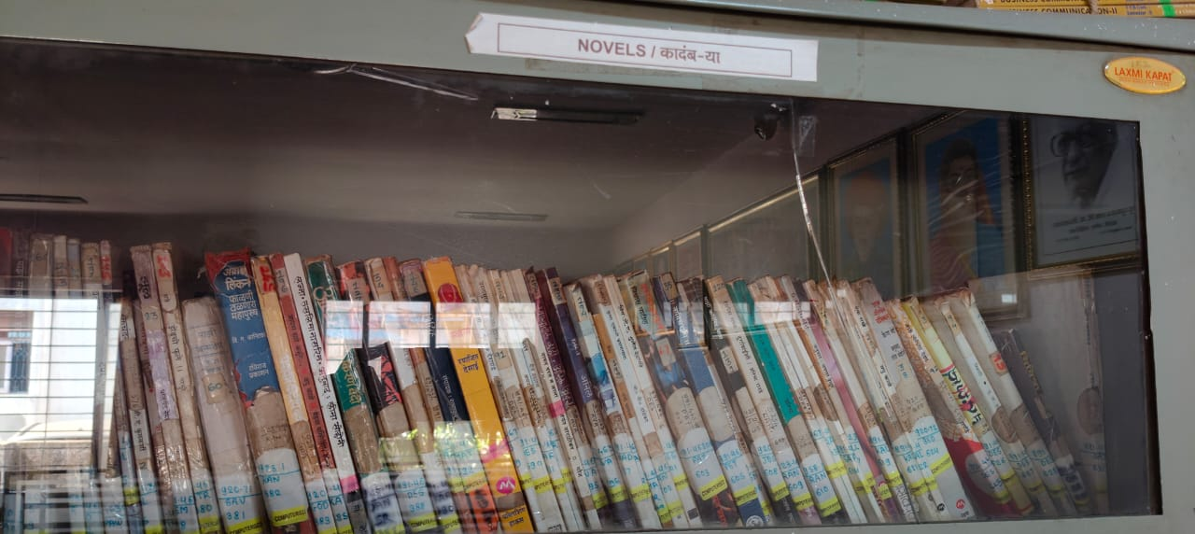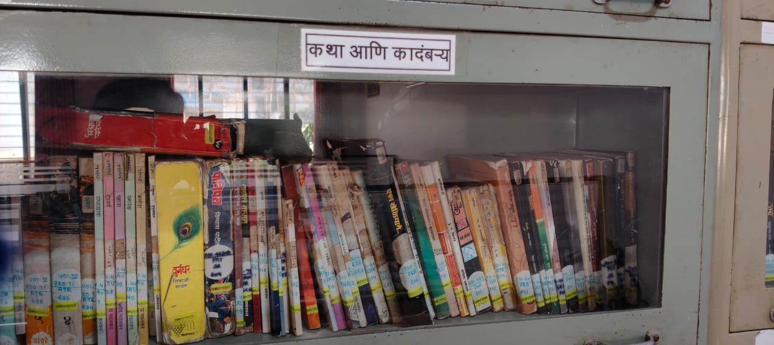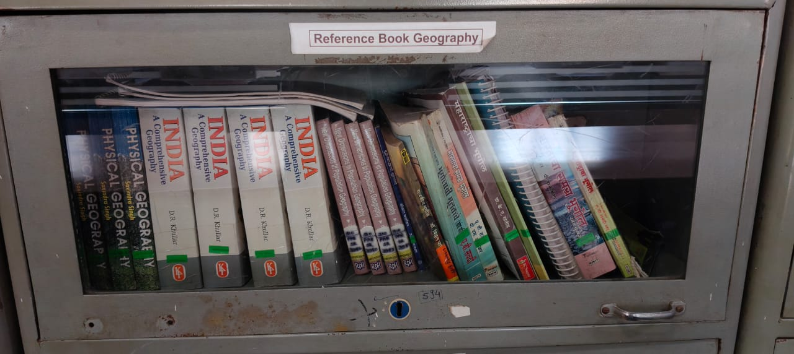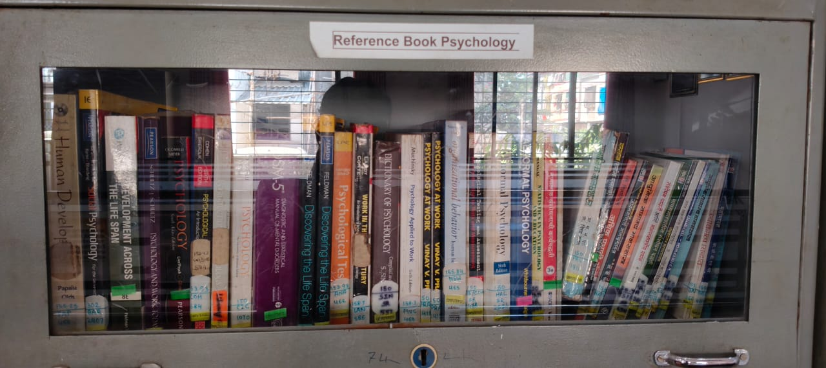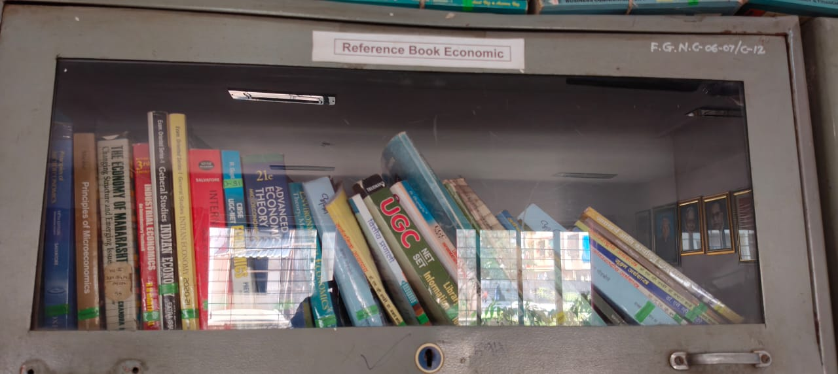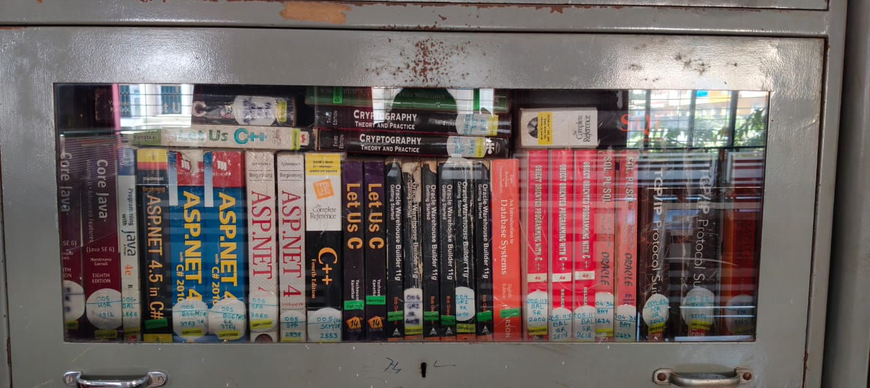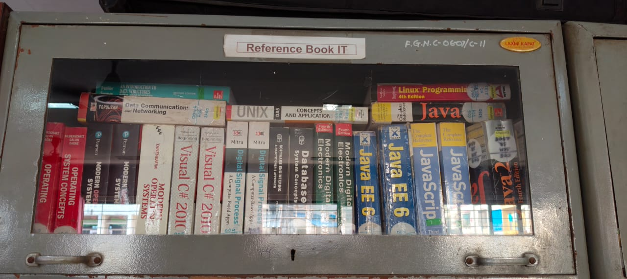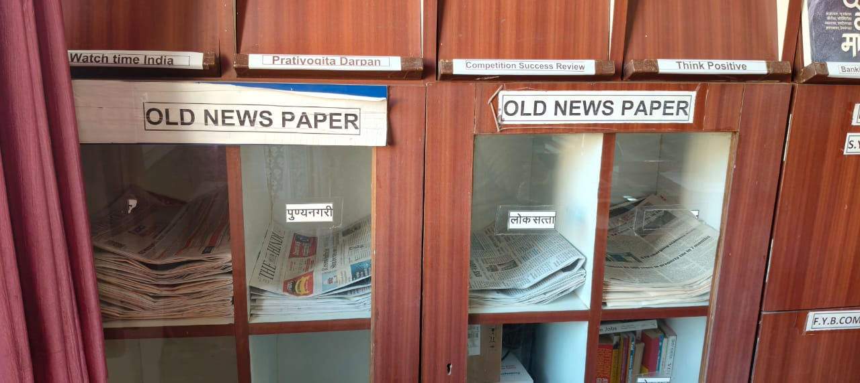

6.2.2

